Classroom Management Plan
Ashley Bratchie, Katrina Kapes, Sarah Stanfar
University of Mary Washington
EDCI 521 Section 1

- We pledge on our honor that we have neither given nor received unauthorized aid on this assignment.
Philosophy of Management
After reading about and considering all of the different management styles, our group is embracing a more flexible approach that encompasses some of the aspects of the democratic approach from Dreikurs, Grunwald, and Pepper, and is grounded in Kounin’s emphasis on instruction. While these methods have a clear infrastructure for management in place, in our opinion they are the best able to accommodate learner differences and ensure that students are vested in their own behavior.
Behavior Expectations
- Class meeting on the first day of class to create a caring community and make students feel part of a whole.
- Have some basic goals for the classroom ready to present to the class on the first day. (Such as: Strive to keep interactions between peers and staff appropriate and mature; Be courteous to others and allow only 1 person to speak at a time; Politely request to leave your seat or the classroom)
- Allow students to come up with ideas for goals for the classroom. Lean towards the basic needs of all students. This also allows students to take ownership and responsibility for the goals of the classroom; therefore, they are more likely to respect them.
- Class meetings (15-30 minutes) once a week to discuss upcoming assignments, questions, concerns and to adjust the goals of the class as necessary.
- Any private matters can be discussed with the teacher at a time before or after class, or before or after school. Have a box where students can slip notes into expressing their concerns or questions in addition to allowing students to email the teacher.
Pre-School Checklist
- Create a detailed syllabus
- Create a layout plan & seating chart for students
- Become familiar with students’ IEPs and 504 plans to see if any behavior modifications must be put into place
- Make classroom inviting by decorating room with posters, pictures, etc.
- Create lesson plans for the first two weeks of school (p. 136)
- Establish a set of class room expectations (not rules, I think we will agree that the students can create their own rules using a classroom contract)
- Create classroom newsletter for parents (to be issued each month to keep parents informed about class activities)
Classroom Arrangement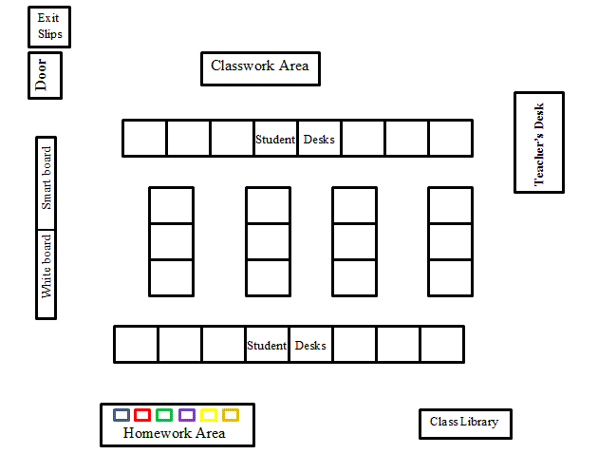
Goals
Within our classroom, we hope to utilize a classroom contract that will allow students to have a voice in both their goals as individual students and their goals for the class as a whole. While we would adapt a classroom contract that sets goals with our students, we would try to frame the meeting so that ultimately the goals would look something like this:
- Our highest goal is to create a positive and caring community environment that supports learning by:
  - Working cooperatively to accomplish learning goals
  - Respecting each other and respecting school property
  - Knowing that the classroom is a safe space and that it is free from bullies, ridicule and other forms of harassment
  - Placing an emphasis on collaborative learning through group work and classroom discussion
  - Encouraging thoughtful exploration, questions, and reflection
Classroom Climate
Creating a warm and caring classroom environment at the secondary level relies on modeling appropriate behavior, establishing boundaries, and using cooperative discipline. Consequently, our approach to creating a caring environment relies on precisely those elements:
- Modeling the appropriate behavior to our students by caring about our students and taking the time to get to know them. Being supportive teachers who go to school events and support student interests is also an effective way to demonstrate what a caring environment looks like.
- Executing a student contract simultaneously establishes boundaries and acts as a cooperative group activity. Students understand what the classroom expectations are because they had a voice in creating them and to do so, they had to work together. Additionally, having classroom meetings throughout the year helps to support and develop the boundaries that the students helped to establish, initially.
- Cooperative discipline helps students take on a leadership role in the classroom- students help solve disputes, prevent problems, and work cooperatively to establish a warm and supportive but orderly classroom environment
Student Knowledge
Name: Date: Course: Block:
1. What are the expectations that you have for me as your teacher?
2. What are the expectations that you have for your classmates?
3. How do you learn best?
4. How do you study?
5. How much time do you think you should set aside outside of class in order to work on homework and studying per week for this course?
6. What days would you like to have tests/quizzes? Why do you feel this way?
7. Are there any topics you look forward to learning about in my class this year?
8. Do you have any goals that you would like to meet this year in this class?
9. Are you involved in any after school activities? (These activities can be in or outside of school).
10. What are your favorite hobbies?
11. What is your favorite book or movie?
Procedures
- Class Meetings
  - During a class meeting, only 1 person speaks at a time, and must have the ball in order to speak.
- Asking Questions:
  - Students should raise their hand to ask questions during class.
  - Do not speak over other students or the teacher.
- Leaving the classroom
  - Students should follow the rules of the school when leaving the classroom. Students may use the restroom once during a class period unless there are special reasons for more. Only 1 student out of the class at a time.
- Staying seated, sharpening pencil, disposal of trash etc.
  - Students should be courteous to their classmates and only sharpen a pencil when no one is talking. They should attempt to sharpen their pencils before class begins when possible.
  - Students should try to stay in their seat, and only throw trash away when appropriate. This is most likely when the student comes into or exits the classroom.
  - Students should stay in their seat during class unless otherwise instructed or for designated classroom activities. Some students may need to move around, but it should not be disruptive to classmates.
- Paperwork for the current class period
  - Class work, handouts, and missed work will be located in a central location for students to pick up when they come into class. Students can look to see if any papers must be picked up prior to the start of class. This eliminates wasting time handing out papers.
- Turing in Homework/Assignments
  - Homework and all assignments including tests and quizzes should be placed in the appropriate bin for the students’ block as soon as the students come into class.
  - Once placed in the bin, students cannot take them out.
- Turning in Late Work
  - Unless otherwise noted, assignments should be turned in on time.
  - Late work should still be placed in the appropriate bin.
  - 5% of the points are deducted after work is one class period late
  - 10% of the points are deducted after work is one week late
  - 50% of the points are deducted after work is turned in later than one week
  - No credit will be given if the assignment is not turned in during the grading period the assignment was due.
  - Special cases on late work may occur from time to time on an individual basis.
Engagement Strategies
- Jigsaw collaborative groups - Break students up into groups (these can be predetermined by the teacher to position students in appropriate groups) to research a particular topic. These students become experts on their topic. Then, the students will switch groups and become teachers. Each student will teach the others about their topic. The teacher should be actively circulating the room to ensure students are on-track and focused.
- Relevant materials – Supplement at least one classroom lesson per unit with a text (trade book), primary source, news article, etc., that is relevant to diverse students. This strategy involves getting to know the students and their cultural backgrounds but will also engage these students.
- Learning stations – Set up several learning stations around the classroom where students will observe, manipulate materials or data, and think critically. Each station should have a set of questions that the students will answer. Students will visit each station in a group.
- Role play – The students can create their own skit or act out part of a lesson. This activity could be completed solely by the students or the teacher could supply students with prewritten roles.
- Video field trips – Find videos on the internet or create your own to show students real life examples of classroom material. This could involve going around in the community to show students examples of recycling, environmental damage, historical landmarks, etc.

